**Osteoporosis Risk Prediction**

The aim of this project is to predict the risk of osteoporosis in patients using a dataset of patients' medical records. Osteoporosis is a condition that weakens bones, making them fragile and more likely to break. It develops slowly over several years and is often only diagnosed when a minor fall or sudden impact causes a bone fracture. The condition is more common in older people, particularly.

# About the dataset

The dataset offers comprehensive information on health factors influencing osteoporosis development, including demographic details, lifestyle choices, medical history, and bone health indicators. It aims to facilitate research in osteoporosis prediction, enabling machine learning models to identify individuals at risk. Analyzing factors like age, gender, hormonal changes, and lifestyle habits can help improve osteoporosis management and prevention strategies.

# Data Dictionary

**Column Description**

ID Unique identifier for each patient

|  |  |
| --- | --- |
| Age | Age of the patient |
| Gender | Gender of the patient |
| Hormonal Changes | Whether the patient has undergone hormonal changes |
| Family History with Osteoporosis | Whether the patient has a family history of osteoporosis |
| Race/Ethnicity | Race or ethnicity of the patient |
| Body Weight | Weight details of the patient |
| Calcium | Calcium levels in the patient's body |
| Vitamin D | Vitamin D levels in the patient's body |
| Physical Activity | Physical activity details of the patient |
| Smoking | Whether the patient smokes |
| Alcohol Consumption | Whether the patient consumes alcohol |
| Medical Conditions | Medical conditions of the patient |
| Medication | Medication details of the patient |
| Prior Fracture | Whether the patient has had a prior fracture |
| Osteoporosis | Whether the patient has osteoporosis |

# Potential analysis in this project

**Predictive Modeling**: Develop machine learning models to predict the probability of osteoporosis based on the provided features. This analysis is crucial for identifying individuals at risk of osteoporosis, enabling early intervention and prevention strategies.

**Feature Importance Analysis**: Determine the importance of each feature in predicting osteoporosis risk. Understanding which factors have the most significant impact on osteoporosis risk can provide insights into the underlying mechanisms and guide targeted interventions.

**Correlation Analysis**: Examine correlations between different features and osteoporosis risk. Identifying strong correlations can help identify potential risk factors or associations that may warrant further investigation or intervention.

**Subgroup Analysis**: Analyze how osteoporosis risk varies across different subgroups based on demographics, lifestyle factors, or medical history. Understanding how risk factors interact within different population groups can inform personalized approaches to osteoporosis prevention and management.

**Model Interpretation**: Interpret the trained models to understand how different features contribute to osteoporosis risk prediction. This analysis can provide insights into the underlying relationships between variables and help healthcare professionals make informed decisions regarding patient care and management strategies.

In [ ]: *#importing the required libraries* **import** numpy **as** np **import** pandas **as** pd **import** matplotlib.pyplot **as** plt **import** seaborn **as** sns

In [ ]: *#Loading the dataset* df **=** pd**.**read_csv("osteoporosis.csv") df**.**head()

Out[ ]: **Hormonal Family Body Calcium**

**Id Age Gender Race/Ethnicity**

**Changes History Weight Intak**

**0** 104866 69 Female Normal Yes Asian Underweight Lo

|  |  |  |  |  |  |  |  |  |
| --- | --- | --- | --- | --- | --- | --- | --- | --- |
| **1** | 101999 | 32 | Female | Normal | Yes | Asian | Underweight | Lo |
| **2** | 106567 | 89 | Female | Postmenopausal | No | Caucasian | Normal | Adequat |
| **3** | 102316 | 78 | Female | Normal | No | Caucasian | Underweight | Adequat |
| **4** | 101944 | 38 | Male | Postmenopausal | Yes | African American | Normal | Lo |

# Data Preprocessing Part 1

|  |
| --- |
| *#checking the shape of the dataset* df**.**shape |

In [ ]:

|  |
| --- |
| *#checking the information of the dataset* df**.**info() |

Out[ ]: (1958, 16) In [ ]:

<class 'pandas.core.frame.DataFrame'>

RangeIndex: 1958 entries, 0 to 1957 Data columns (total 16 columns):

# Column Non-Null Count Dtype --- ------ -------------- ----- 0 Id 1958 non-null int64

1. Age 1958 non-null int64
2. Gender 1958 non-null object
3. Hormonal Changes 1958 non-null object
4. Family History 1958 non-null object
5. Race/Ethnicity 1958 non-null object
6. Body Weight 1958 non-null object
7. Calcium Intake 1958 non-null object
8. Vitamin D Intake 1958 non-null object
9. Physical Activity 1958 non-null object
10. Smoking 1958 non-null object
11. Alcohol Consumption 970 non-null object
12. Medical Conditions 1311 non-null object
13. Medications 973 non-null object
14. Prior Fractures 1958 non-null object 15 Osteoporosis 1958 non-null int64 dtypes: int64(3), object(13) memory usage: 244.9+ KB

Few columns have missing values, so before proceeding with the analysis, I will first handle the missing values in the dataset.

|  |
| --- |
| *#columns with missing values*  columns_with_missing_values **=** df**.**columns[df**.**isnull()**.**any()]  *#missing value percentage* print("Missing value percentage") **for** column **in** columns_with_missing_values:  print(column,":",df[column]**.**isnull()**.**sum()**/**df**.**shape[0]**\***100) |

In [ ]:

Missing value percentage

Alcohol Consumption : 50.45965270684371

Medical Conditions : 33.04392236976506

Medications : 50.30643513789581

Alcohol Consumption and Medications columns have more than 50% missing values, I will be replacing these missing values with "None" as it is possible that the patient does not consume alcohol or take any medications. The same goes for the Medical Conditions column.

However, the columns with more than 50% missing values might not be much useful for the analysis, but still I am keeping them for the remaining 50% of the data.

|  |
| --- |
| *#replace missing values with "None"* df**.**fillna("None",inplace**=True**) |

In [ ]:

The column ID is an identifier and irrelevant for the analysis, so I will drop this column.

|  |
| --- |
| df **=** df**.**drop(['Id'], axis**=**1) |

In [ ]:

|  |
| --- |
| *#value counts of categorical columns*  categorical_columns **=** df**.**select_dtypes(include**=**['object'])**.**columns **for** column **in** categorical_columns: print(df[column]**.**value_counts()) |

In [ ]:

Gender

Male 992

Female 966

Name: count, dtype: int64

Hormonal Changes

Normal 981

Postmenopausal 977

Name: count, dtype: int64

Family History

No 998

Yes 960

Name: count, dtype: int64

Race/Ethnicity

African American 681

Caucasian 646

Asian 631

Name: count, dtype: int64

Body Weight

Normal 1027

Underweight 931

Name: count, dtype: int64

Calcium Intake

Low 1004

Adequate 954

Name: count, dtype: int64

Vitamin D Intake

Sufficient 1011

Insufficient 947

Name: count, dtype: int64

Physical Activity

Active 1021

Sedentary 937

Name: count, dtype: int64

Smoking

Yes 982

No 976

Name: count, dtype: int64

Alcohol Consumption

None 988

Moderate 970

Name: count, dtype: int64

Medical Conditions

Hyperthyroidism 678

None 647

Rheumatoid Arthritis 633

Name: count, dtype: int64

Medications

None 985

Corticosteroids 973

Name: count, dtype: int64

Prior Fractures

Yes 983

No 975

Name: count, dtype: int64

Descriptive Statistics

|  |
| --- |
| df**.**describe() |

In [ ]:

Out[ ]: **Age Osteoporosis**

|  |  |  |  |
| --- | --- | --- | --- |
| **count** | 1958.000000 | | 1958.000000 |
| **mean** | |  | 39.101124 | 0.500000 | |
| **std** | |  | 21.355424 | 0.500128 | |
| **min** | |  | 18.000000 | 0.000000 | |
| **25%** | |  | 21.000000 | 0.000000 | |
| **50%** | |  | 32.000000 | 0.500000 | |
| **75%** | |  | 53.000000 | 1.000000 | |
| **max** | |  | 90.000000 | 1.000000 | |

In [ ]:

Out[ ]:

|  |  |  |  |  |  |
| --- | --- | --- | --- | --- | --- |
| df**.**head() |  |  |  |  |  |
| **Age Gender** | **Hormonal**  **Changes** | **Family**  **History** | **Race/Ethnicity** | **Body Weight** | **Calcium Vitam**  **Intake** |

**In**

|  |  |  |  |  |  |  |  |  |
| --- | --- | --- | --- | --- | --- | --- | --- | --- |
| **0** | 69 | Female | Normal | Yes | Asian | Underweight | Low | Suff |
| **1** | | 32 | Female | Normal | Yes | Asian | Underweight | Low | Suff | |
| **2** | | 89 | Female | Postmenopausal | No | Caucasian | Normal | Adequate | Suff | |
| **3** | | 78 | Female | Normal | No | Caucasian | Underweight | Adequate | Insuff | |
| **4** | | 38 | Male | Postmenopausal | Yes | African American | Normal | Low | Suff | |

# Exploratory Data Analysis

In the exploratory data analysis, I will be looking at the distribution of the data acroos all the variables and relationships between the variables and the target variable. For this I will be plotting the dataset variables in different graphs and draw out insights from them

## Target Variable Distribution

In [ ]: *#pie chart for the target variable (Osteoporosis)* plt**.**figure(figsize**=**(5,5)) df['Osteoporosis']**.**value_counts()**.**plot**.**pie(autopct**=**'%1.1f%%')**.**set_title('Osteopo

Out[ ]: Text(0.5, 1.0, 'Osteoporosis')

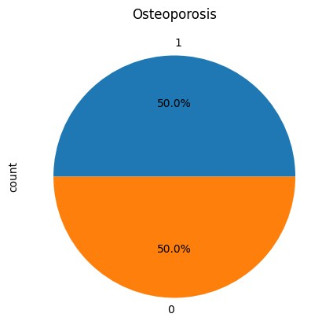

The above pie chart shows that the dataset is perfectly balanced with 50% of the patients having osteoporosis and 50% not having osteoporosis, which means that the dataset is not biased towards any class.

## Age and Osteoporosis

In [ ]:

|  |
| --- |
| *#two layer histogram for the Age and Osteoporosis* plt**.**figure(figsize**=**(10,5)) df[df['Osteoporosis']**==**1]['Age']**.**plot**.**hist(bins**=**30, alpha**=**0.5, color**=**'blue', la df[df['Osteoporosis']**==**0]['Age']**.**plot**.**hist(bins**=**30, alpha**=**0.5, color**=**'red', lab  *#legends and title* plt**.**legend() plt**.**xlabel('Age') plt**.**title('Osteoporosis by Age') |

b e

Out[ ]: Text(0.5, 1.0, 'Osteoporosis by Age')

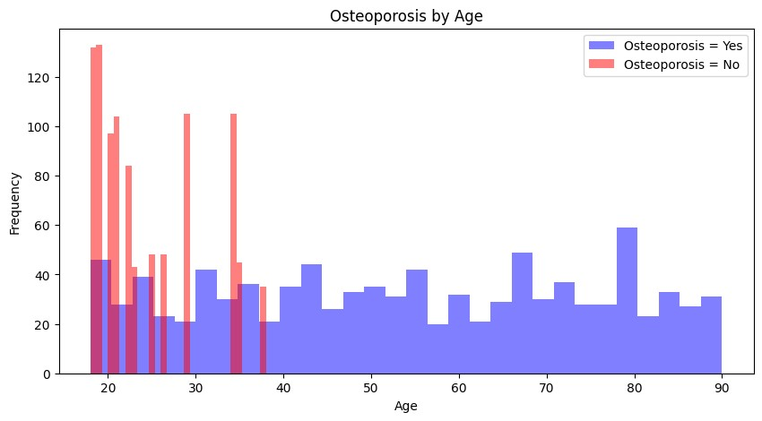

This graph shows relation between the risk of osteoporosis and the age of the patient. In the graph we can see that that there is significant risk of osteoporosis in patients of all ages but patients between the ages 20 to 40 have significantly much lower risk of osteoporosis. This highlights that fact that younger patients are less likely to have osteoporosis.

## Gender and Osteoporosis

In [ ]: sns**.**countplot(x**=**'Gender', data**=**df, hue**=**'Osteoporosis')**.**set_title('Gender vs Oste

Out[ ]: Text(0.5, 1.0, 'Gender vs Osteoporosis')

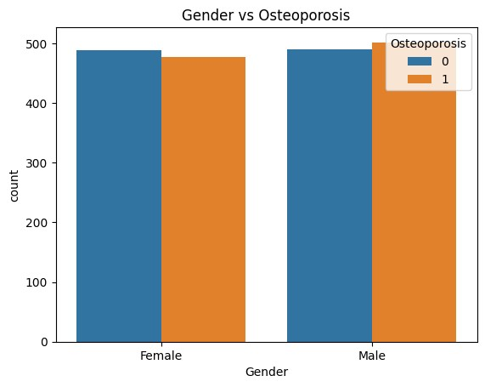

In this graph, we can visualize the relationship between gender and the risk of osteoporosis. The graph shows that there is no concrete relationship between gender and the risk of osteoporosis, however, according to the numbers in the dataset, the males tend to have slightly higher number of osteoporosis cases than females, but the difference is not significant. Therefore, gender could be a weak predictor for osteoporosis.

## Hormonal Changes and Osteoporosis

In [ ]: *#hormonal changes and Osteoporosis* sns**.**countplot(x**=**'Hormonal Changes',data**=**df,hue**=**'Osteoporosis')**.**set_title('Hormon

Out[ ]: Text(0.5, 1.0, 'Hormonal changes and Osteoporosis')

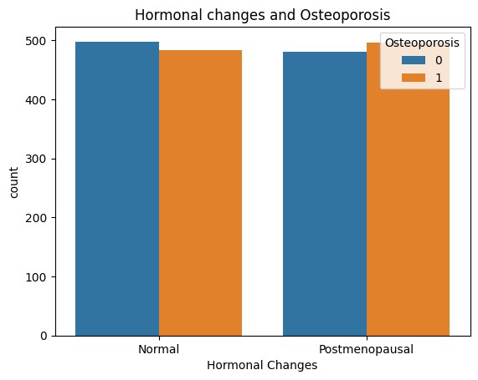

*Note: Here Postmenopausal is not only for females, but it also reflects the cap on testosterone production in males, therefore for both genders, the hormonal changes are termed as postmenopausal.*

The graph shows that patients who have undergone hormonal changes have a higher risk of osteoporosis than those who have not undergone hormonal changes. This indicates that hormonal changes can be a significant risk factor for osteoporosis. This highlights that our hormones contribute in making our bones strong

## Family History and Osteoporosis

In [ ]: sns**.**countplot(x **=** "Family History", data **=** df, hue **=** "Osteoporosis")**.**set_title("

Out[ ]: Text(0.5, 1.0, 'Family History and Osteoporosis')

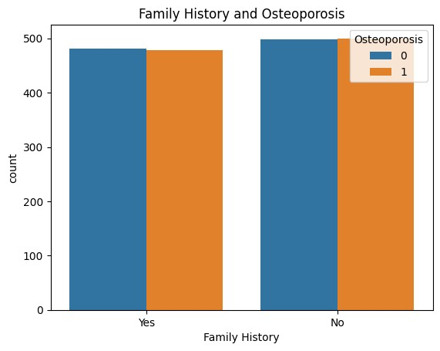

It is believed that genetics play a important role in the development of a disease. The graph shows the relationship between family history of osteoporosis and the risk of osteoporosis. But in the graph there is not much differnece in both cases regarding the risk of osteoporosis. Therefore, family history couldn;t be considered a predictor for osteoporosis.

## Race/Ethnicity and Osteoporosis

In [ ]: sns**.**countplot(x**=**"Race/Ethnicity", data **=** df, hue **=** "Osteoporosis")**.**set_title("Ra

Out[ ]: Text(0.5, 1.0, 'Race/Ethnicity and Osteoporosis')

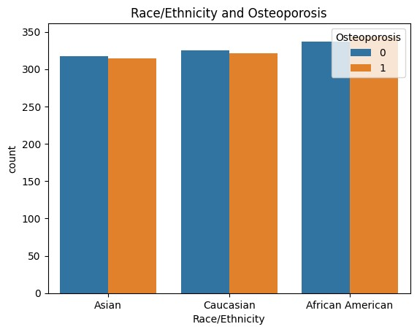

This graph shows the relationship between Race/Ethnicity and the risk of osteoporosis. The graph shows that the risk of osteoporosis is almost similar with no concrete relationship between the race and risk of osteoporosis.

## Body Weight and Osteoporosis

|  |
| --- |
| sns**.**countplot(x**=**"Body Weight", data **=** df, hue **=** "Osteoporosis")**.**set_title("Body |

In [ ]:

Out[ ]: Text(0.5, 1.0, 'Body Weight and Osteoporosis')

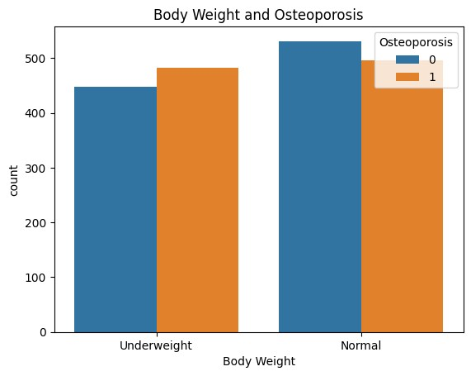

Body weight is an important factor in determining the risk of osteoporosis. The graph shows that patients with lower body weight have a higher risk of osteoporosis than those with higher body weight. This indicates that body weight can be a significant risk factor for osteoporosis. This highlights that our body weight contributes in making our bones strong.

## Nutrition and Osteoporosis

In [ ]: fig, ax **=** plt**.**subplots(1, 2, figsize**=**(20, 6)) sns**.**countplot(x**=**'Calcium Intake', data**=**df, ax**=**ax[0], hue**=**'Osteoporosis')**.**set_tit sns**.**countplot(x**=**'Vitamin D Intake', data**=**df, ax**=**ax[1], hue**=**'Osteoporosis')**.**set_t

Out[ ]: Text(0.5, 1.0, 'Vitamin D Intake and Osteoporosis')

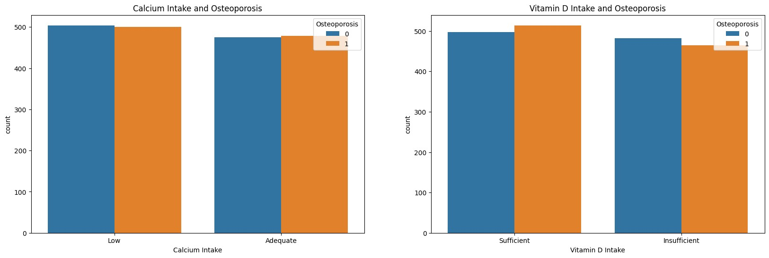

Nutrition and Osteoporosis are closely related. The graph shows that patients with lower calcium and vitamin D levels have a higher risk of osteoporosis than those with higher calcium and vitamin D levels. This indicates that nutrition can be a significant risk factor for osteoporosis. This highlights that our nutrition contributes in making our bones strong.

## Physical Activity and Osteoporosis

|  |
| --- |
| sns**.**countplot(x**=**'Physical Activity', data**=**df, hue**=**'Osteoporosis')**.**set_title('Ph |

In [ ]:y

Out[ ]: Text(0.5, 1.0, 'Physical Activity and Osteoporosis')

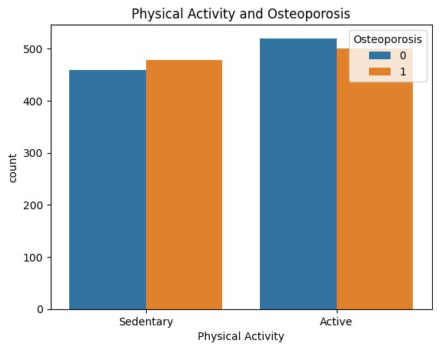

Physical Activity and Osteoporosis have a relation between them. The graph shows that patients with active physical acitve lifestyle lower risk of osteoporosis as compared to the patients with sedentary lifestyle.

## Smoking and Alcohol Consumption and Osteoporosis

In [ ]:

|  |
| --- |
| fig, ax **=** plt**.**subplots(1, 2, figsize**=**(20, 6)) sns**.**countplot(x**=**'Smoking', data**=**df, ax**=**ax[0], hue**=**'Osteoporosis')**.**set_title('Sm sns**.**countplot(x**=**'Alcohol Consumption', data**=**df, ax**=**ax[1], hue**=**'Osteoporosis')**.**s |

o e

Out[ ]: Text(0.5, 1.0, 'Alcohol Consumption and Osteoporosis')

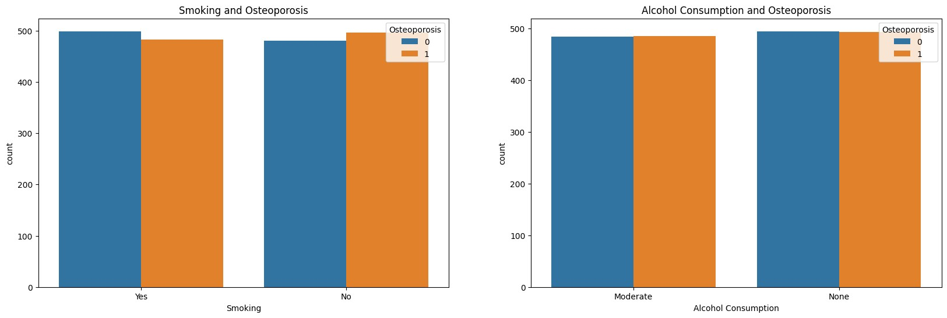

Smoking and Alcohol Consumption are one of those factors that could have adverse effect on a patients health. Here, the graph shows that patients who smoke and consume alcohol does not relate to the risk of osteoporosis. This indicates that smoking and alcohol consumption are not significant risk factors for osteoporosis.

## Medical Conditions and Medications and Osteoporosis

In [ ]:

|  |
| --- |
| fig, ax **=** plt**.**subplots(1, 2, figsize**=**(20, 6)) sns**.**countplot(x**=**'Medical Conditions', data**=**df, ax**=**ax[0], hue**=**'Osteoporosis')**.**se sns**.**countplot(x**=**'Medications', data**=**df, ax**=**ax[1], hue**=**'Osteoporosis')**.**set_title |

t (

Out[ ]: Text(0.5, 1.0, 'Medications and Osteoporosis')

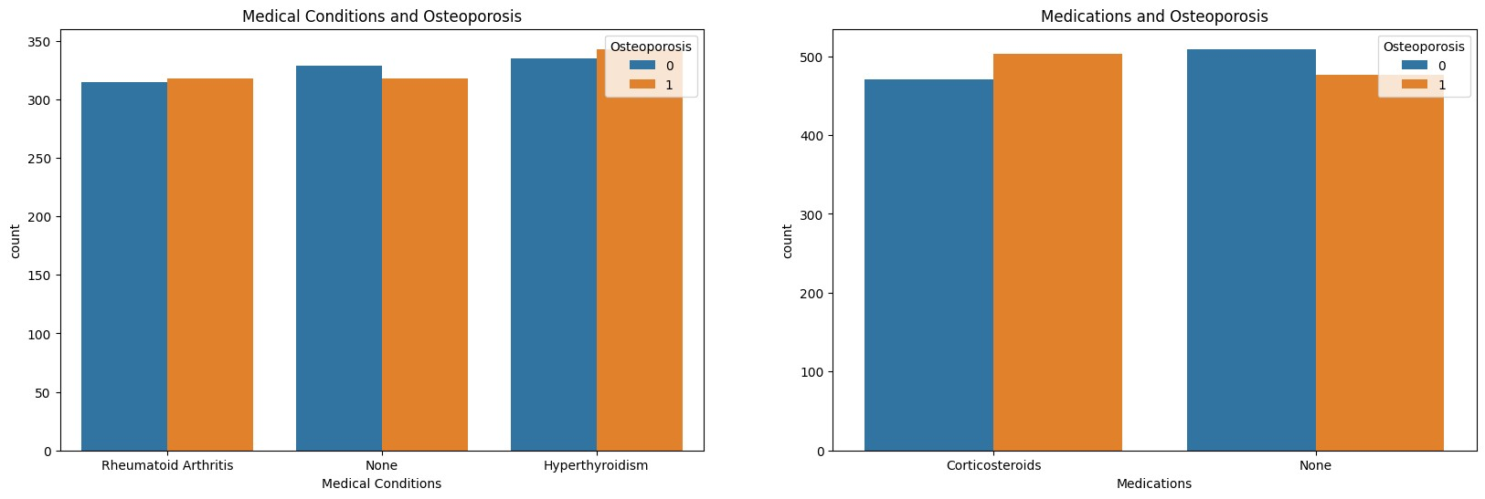

The graph shows that patients with medical conditions like Hyperthyroidism have a higher risk of osteoporosis than those without medical conditions. This indicates that medical conditions can be a significant risk factor for osteoporosis. In addition to that patients who consume medications like Corticosteriods have higher risk of osteoporosis.

## Prior Fracture and Osteoporosis

|  |
| --- |
| sns**.**countplot(x**=**'Prior Fractures', data**=**df, hue**=**'Osteoporosis')**.**set_title('Prio |

In [ ]:r

Out[ ]: Text(0.5, 1.0, 'Prior Fractures and Osteoporosis')

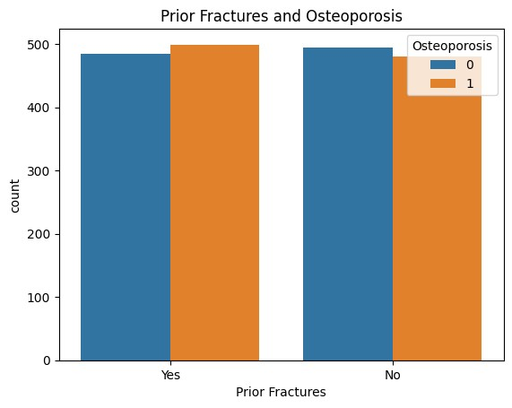

This graph shows the relation between the prior incident of fractures and risk of osteoporosis and from the graph it is clear that there is no concrete relationship between the prior incident of fractures and risk of osteoporosis.

# Data Preprocessing Part 2

## Label Encoding the Categorical Variables

|  |
| --- |
| *#columns for label encoding*  cols **=** df**.**select_dtypes(include**=**['object'])**.**columns  *#label encoding*  **from** sklearn.preprocessing **import** LabelEncoder le **=** LabelEncoder()  **for** col **in** cols:  df[col] **=** le**.**fit_transform(df[col]) print(col,":",df[col]**.**unique()) |

In [ ]:

Gender : [0 1]

Hormonal Changes : [0 1]

Family History : [1 0]

Race/Ethnicity : [1 2 0]

Body Weight : [1 0]

Calcium Intake : [1 0]

Vitamin D Intake : [1 0]

Physical Activity : [1 0]

Smoking : [1 0]

Alcohol Consumption : [0 1]

Medical Conditions : [2 1 0]

Medications : [0 1]

Prior Fractures : [1 0]

# Correlation Matrix Heatmap

|  |
| --- |
| plt**.**figure(figsize**=**(20,20)) sns**.**heatmap(df**.**corr(), annot**=True**) |

In [ ]:

Out[ ]: <Axes: >

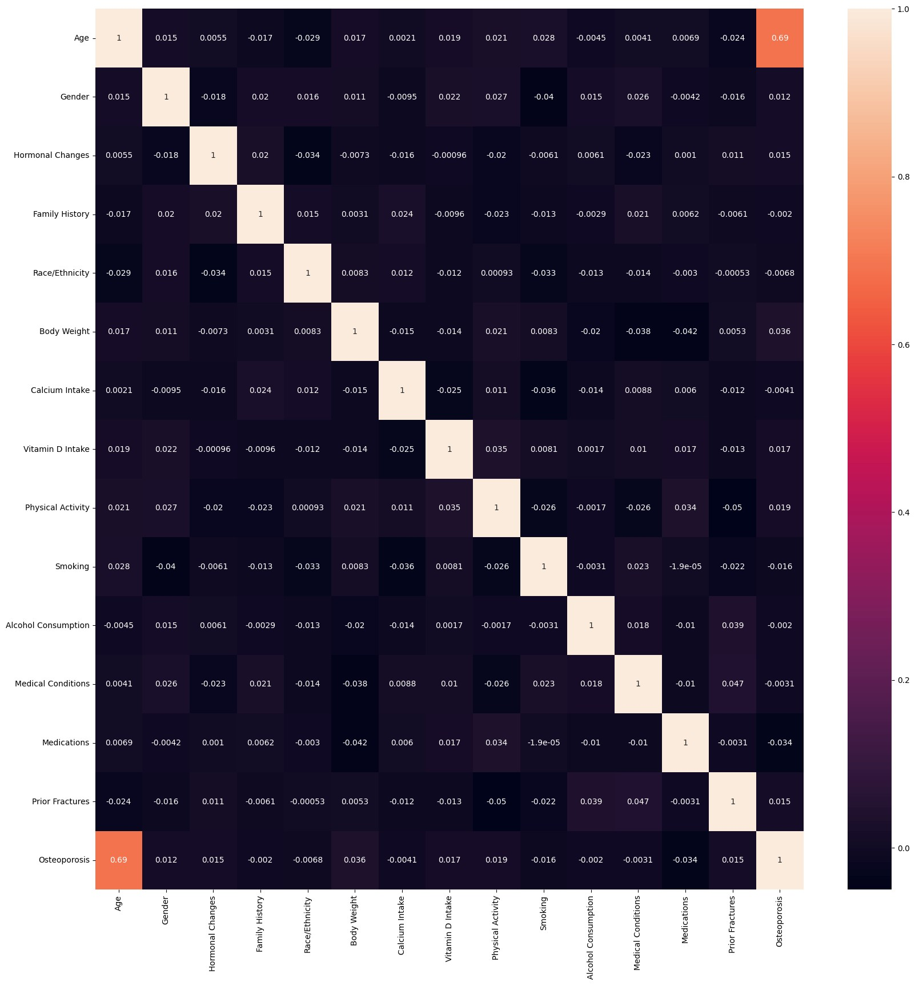

# Train Test Split

In [ ]: **from** sklearn.model_selection **import** train_test_split

X_train, X_test, y_train, y_test **=** train_test_split(df**.**drop('Osteoporosis',axis**=**

# Ostheoporosis Risk Prediction Models

For predicting the risk of osteoporosis, I will be using the following models:

Logistic Regression

Random Forest Classifier

Decision Tree Classifier Support Vector Classifier

## Logistic Regression

|  |
| --- |
| **from** sklearn.linear_model **import** LogisticRegression  *#creating logistic regression object* logmodel **=** LogisticRegression() |

In [ ]:

### Hyperparameter Tuning using GridSearchCV

|  |
| --- |
| **from** sklearn.model_selection **import** GridSearchCV  *#parameters for grid search*  param_grid **=** {'C': [0.1, 1, 10, 100, 1000],  'penalty': ['l1', 'l2'], 'solver': ['liblinear'],  'max_iter': [100, 1000, 2500, 5000],  'multi_class': ['auto', 'ovr'], 'random_state': [0,42,101]}  *#grid search object*  grid **=** GridSearchCV(logmodel,param_grid,refit**=True**,verbose**=**3,cv**=**5,n_jobs**=-**1)  *#fitting the data* grid**.**fit(X_train,y_train)  *#best parameters* print(grid**.**best_params_) |

In [ ]:

Fitting 5 folds for each of 240 candidates, totalling 1200 fits

{'C': 0.1, 'max_iter': 100, 'multi_class': 'auto', 'penalty': 'l2', 'random_stat e': 0, 'solver': 'liblinear'}

In [ ]:

|  |
| --- |
| *#logistic regression with best parameters*  logmodel **=** LogisticRegression(C**=**0.1, max_iter**=**100, penalty**=**'l2', random_state**=**0  *#fitting the data*  logmodel**.**fit(X_train,y_train)  *#training accuracy* |

,

print("Training accuracy:",logmodel**.**score(X_train,y_train))

*#prediction* lr_pred **=** logmodel**.**predict(X_test)

Training accuracy: 0.8284671532846716

## Random Forest Classifier

|  |
| --- |
| **from** sklearn.ensemble **import** RandomForestClassifier  *#creating random forest object* rfc **=** RandomForestClassifier() |

In [ ]:

### Hyperparameter Tuning using GridSearchCV

|  |
| --- |
| *#parameters for grid search*  param_grid **=** {'criterion': ['gini', 'entropy'],  'max_depth': [10, 20, 30],  'min_samples_split': [2, 5, 10],  'min_samples_leaf': [2,5,10], 'random_state': [0,42,101]}  *#grid search object*  grid **=** GridSearchCV(rfc,param_grid,refit**=True**,verbose**=**3,cv**=**5,n_jobs**=-**1)  *#fitting the data* grid**.**fit(X_train,y_train)  *#best parameters* print(grid**.**best_params_) |

In [ ]:

Fitting 5 folds for each of 162 candidates, totalling 810 fits

{'criterion': 'gini', 'max_depth': 20, 'min_samples_leaf': 2, 'min_samples_spli t': 2, 'random_state': 42}

In [ ]:

|  |
| --- |
| *#random forest with best parameters*  rfc **=** RandomForestClassifier(criterion**=**'gini', max_depth**=**10, min_samples_leaf**=**2  *#fitting the data* rfc**.**fit(X_train,y_train)  *#training accuracy*  print("Training accuracy:",rfc**.**score(X_train,y_train))  *#prediction*  rfc_pred **=** rfc**.**predict(X_test) |

,

Training accuracy: 0.9401459854014599

## Decision Tree Classifier

|  |
| --- |
| **from** sklearn.tree **import** DecisionTreeClassifier  *#creating decision tree object* dtree **=** DecisionTreeClassifier() |

In [ ]:

### Hyperparameter Tuning using GridSearchCV

|  |
| --- |
| *#parameters for grid search*  param_grid **=** {'criterion': ['gini', 'entropy'],  'max_depth': [10, 20, 30],  'min_samples_split': [2, 5, 10],  'min_samples_leaf': [2,5,10], 'random_state': [0,42,101]}  *#grid search object*  grid **=** GridSearchCV(dtree,param_grid,refit**=True**,verbose**=**3,cv**=**5,n_jobs**=-**1)  *#fitting the data* grid**.**fit(X_train,y_train)  *#best parameters* print(grid**.**best_params_) |

In [ ]:

Fitting 5 folds for each of 162 candidates, totalling 810 fits

{'criterion': 'entropy', 'max_depth': 10, 'min_samples_leaf': 10, 'min_samples_sp lit': 2, 'random_state': 0}

|  |
| --- |
| *#decision tree with best parameters*  dtree **=** DecisionTreeClassifier(criterion**=**'entropy', max_depth**=**10, min_samples_l  *#fitting the data* dtree**.**fit(X_train,y_train)  *#training accuracy*  print("Training accuracy:",dtree**.**score(X_train,y_train))  *#prediction*  dtree_pred **=** dtree**.**predict(X_test) |

In [ ]: e

Training accuracy: 0.9094890510948905

## Support Vector Classifier

|  |
| --- |
| **from** sklearn.svm **import** SVC  *#creating support vector classifier object* svc **=** SVC() |

In [ ]:

### Hyperparameter Tuning using GridSearchCV

|  |
| --- |
| *#parameters for grid search* param_grid **=** {'C': [0.1, 1, 10, 100], 'degree': [2, 3, 4, 5],  'gamma': ['scale', 'auto'],  'random_state': [0,42,101]}  *#grid search object*  grid **=** GridSearchCV(svc,param_grid,refit**=True**,verbose**=**3,cv**=**5,n_jobs**=-**1)  *#fitting the data* grid**.**fit(X_train,y_train)  *#best parameters* print(grid**.**best_params_) |

In [ ]:

Fitting 5 folds for each of 96 candidates, totalling 480 fits

|  |
| --- |
| *#support vector classifier with best parameters*  svc **=** SVC(C**=**0.1, degree**=**2, gamma**=**'auto', random_state**=**0, kernel**=**'linear')  *#fitting the data* svc**.**fit(X_train,y_train)  *#training accuracy*  print("Training accuracy:",svc**.**score(X_train,y_train))  *#prediction*  svc_pred **=** svc**.**predict(X_test) |

{'C': 1, 'degree': 2, 'gamma': 'auto', 'random_state': 0} In [ ]:

Training accuracy: 0.8350364963503649

# Model Evaluation

## Confusion Matrix

In [ ]:

|  |
| --- |
| **from** sklearn.metrics **import** confusion_matrix fig, ax **=** plt**.**subplots(2, 2, figsize**=**(15, 15))  *#confusion matrix for logistic regression* cm **=** confusion_matrix(y_test, lr_pred)  sns**.**heatmap(cm, annot**=True**, ax **=** ax[0,0], fmt**=**'g')**.**set_title('Logistic Regressi  *#confusion matrix for random forest* cm **=** confusion_matrix(y_test, rfc_pred)  sns**.**heatmap(cm, annot**=True**, ax **=** ax[0,1], fmt**=**'g')**.**set_title('Random Forest Cla  *#confusion matrix for decision tree* cm **=** confusion_matrix(y_test, dtree_pred)  sns**.**heatmap(cm, annot**=True**, ax **=** ax[1,0], fmt**=**'g')**.**set_title('Decision Tree Cla  *#confusion matrix for support vector classifier* cm **=** confusion_matrix(y_test, svc_pred) sns**.**heatmap(cm, annot**=True**, ax **=** ax[1,1], fmt**=**'g')**.**set_title('Support Vector Cl |

o

s

s

a

Out[ ]: Text(0.5, 1.0, 'Support Vector Classifier')

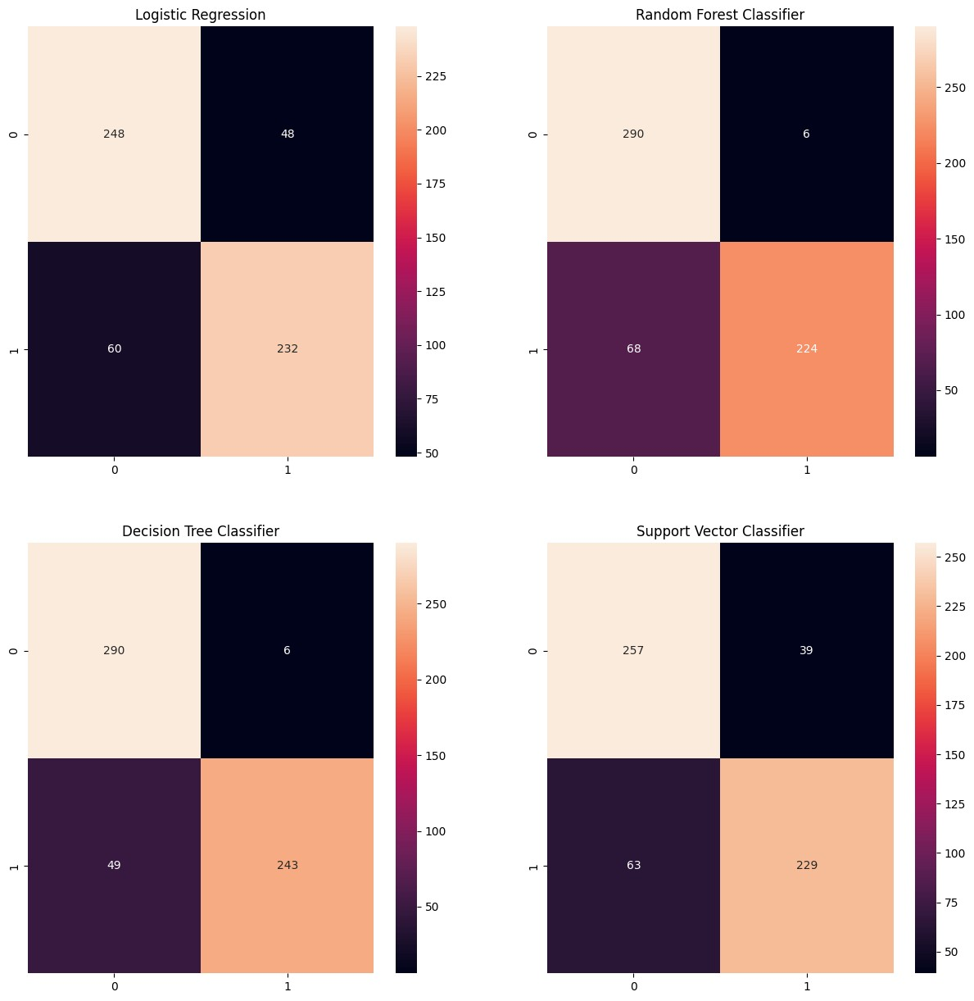

## Model Accuracy

In [ ]:

|  |
| --- |
| *#Bar chart for the accuracy of the models* **from** sklearn.metrics **import** accuracy_score models **=** ['Logistic Regression', 'Random Forest', 'Decision Tree', 'Support Vec accuracy **=** [accuracy_score(y_test, lr_pred), accuracy_score(y_test, rfc_pred), plt**.**figure(figsize**=**(10,5)) sns**.**barplot(x**=**models, y**=**accuracy)**.**set_title('Model Accuracy') |

t a

Out[ ]: Text(0.5, 1.0, 'Model Accuracy')

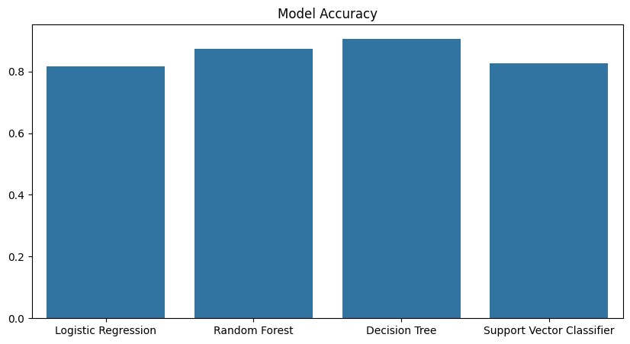

## Model Metrics

|  |
| --- |
| **from** sklearn.metrics **import** mean_absolute_error, mean_squared_error, r2_score,  fig, ax **=** plt**.**subplots(2,2, figsize**=**(15, 15)) models **=** ['Logistic Regression', 'Random Forest', 'Decision Tree', 'Support Vec mae **=** [mean_absolute_error(y_test, lr_pred), mean_absolute_error(y_test, rfc_pr mse **=** [mean_squared_error(y_test, lr_pred), mean_squared_error(y_test, rfc_pred rmse **=** [np**.**sqrt(mean_squared_error(y_test, lr_pred)), np**.**sqrt(mean_squared_erro r2 **=** [r2_score(y_test, lr_pred), r2_score(y_test, rfc_pred), r2_score(y_test, d  *#Mean Absolute Error*  sns**.**barplot(x**=**models, y**=**mae, ax**=**ax[0,0])**.**set_title('Mean Absolute Error')  *#Mean Squared Error*  sns**.**barplot(x**=**models, y**=**mse, ax**=**ax[0,1])**.**set_title('Mean Squared Error')  *#Root Mean Squared Error*  sns**.**barplot(x**=**models, y**=**rmse, ax**=**ax[1,0])**.**set_title('Root Mean Squared Error')  *#R2 Score*  sns**.**barplot(x**=**models, y**=**r2, ax**=**ax[1,1])**.**set_title('R2 Score') |

In [ ]:r

t e ) r t

Out[ ]: Text(0.5, 1.0, 'R2 Score')

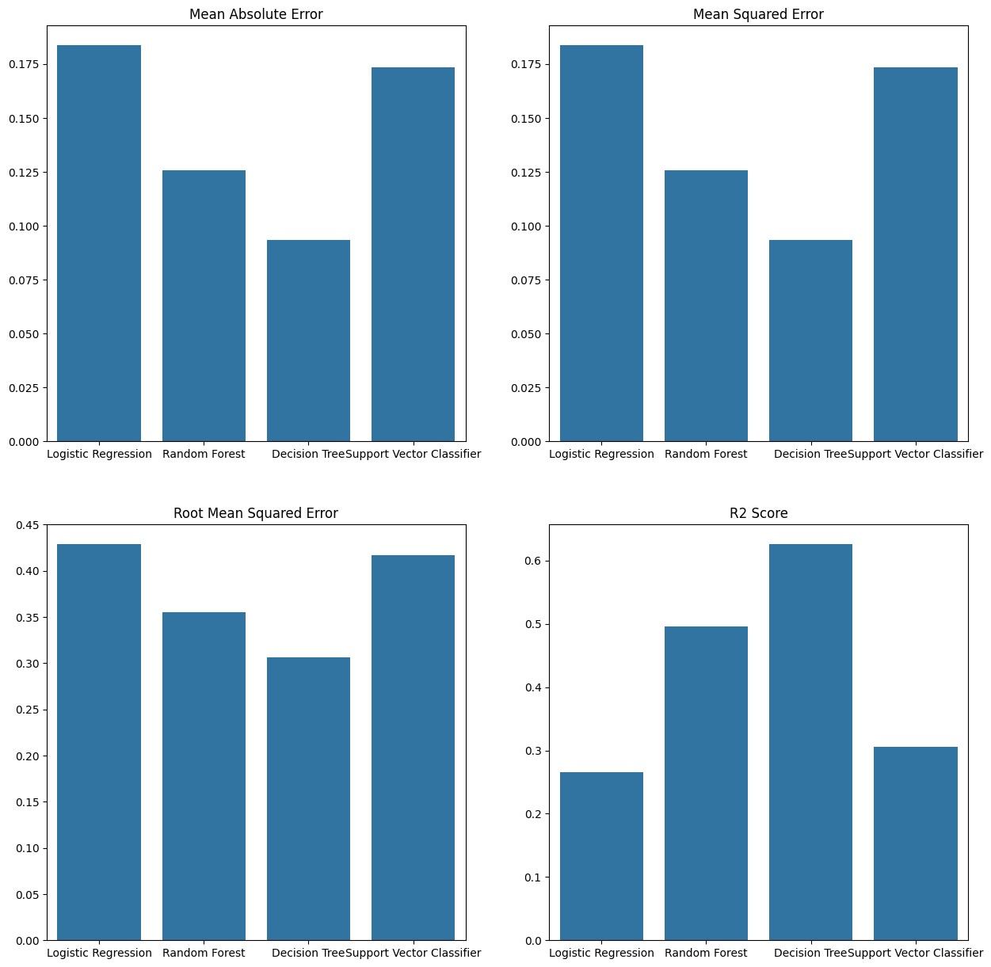

# Feature Importance Analysis

In [ ]:

|  |
| --- |
| fig, ax **=** plt**.**subplots(2, 2, figsize**=**(20, 20))  *#Feature Importance graph for Logistic Regression* coeff **=** list(logmodel**.**coef_[0]) labels **=** list(df**.**drop('Osteoporosis',axis**=**1)**.**columns) features **=** pd**.**DataFrame() features['Features'] **=** labels features['Importance'] **=** coeff features**.**sort_values(by**=**['Importance'], ascending**=True**, inplace**=True**) features **=** features**.**set_index('Features')  features**.**plot(kind**=**'barh', ax**=**ax[0,0])**.**set_title('Feature Importance for Logist  *#Feature Importance graph for Random Forest* coeff **=** list(rfc**.**feature_importances_) labels **=** list(df**.**drop('Osteoporosis',axis**=**1)**.**columns) features **=** pd**.**DataFrame() features['Features'] **=** labels features['Importance'] **=** coeff features**.**sort_values(by**=**['Importance'], ascending**=True**, inplace**=True**) features **=** features**.**set_index('Features') features**.**plot(kind**=**'barh', ax**=**ax[0,1])**.**set_title('Feature Importance for Random |

|  |
| --- |
| *#Feature Importance graph for Decision Tree* coeff **=** list(dtree**.**feature_importances_) labels **=** list(df**.**drop('Osteoporosis',axis**=**1)**.**columns) features **=** pd**.**DataFrame() features['Features'] **=** labels features['Importance'] **=** coeff features**.**sort_values(by**=**['Importance'], ascending**=True**, inplace**=True**) features **=** features**.**set_index('Features')  features**.**plot(kind**=**'barh', ax**=**ax[1,0])**.**set_title('Feature Importance for Decisi  *#Feature Importance graph for Support Vector Classifier* coeff **=** list(svc**.**coef_[0]) labels **=** list(df**.**drop('Osteoporosis',axis**=**1)**.**columns) features **=** pd**.**DataFrame() features['Features'] **=** labels features['Importance'] **=** coeff features**.**sort_values(by**=**['Importance'], ascending**=True**, inplace**=True**) features **=** features**.**set_index('Features') features**.**plot(kind**=**'barh', ax**=**ax[1,1])**.**set_title('Feature Importance for Suppor |

i o t

Out[ ]: Text(0.5, 1.0, 'Feature Importance for Support Vector Classifier')

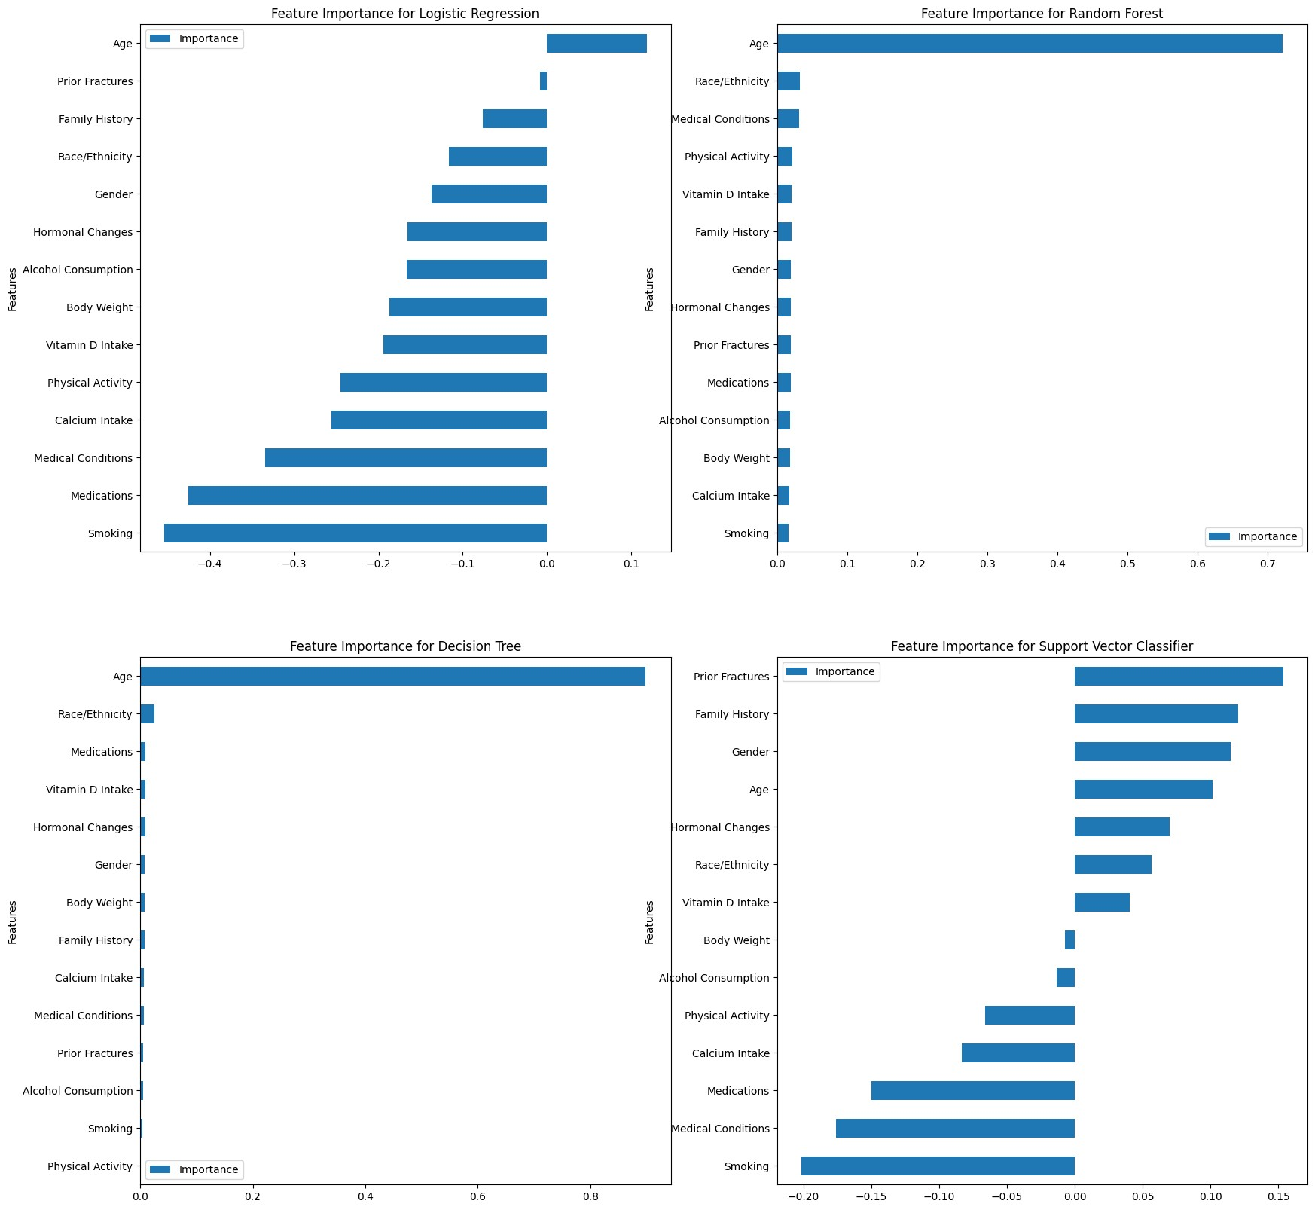

# Conclusion

In this project, I developed machine learning models to predict the risk of osteoporosis in patients based on their medical records. I analyzed the dataset, performed exploratory data analysis, and developed predictive models using logistic regression, random forest classifier, decision tree classifier, and support vector classifier. I evaluated the models using confusion matrix, accuracy, precision, recall, and F1 score metrics.

From the exploratory data analysis, i have found that certain factors like Age, Hormona Changes, Medical Conditions, Medications, Lifestyle and nutrition are responsible for the risk of osteoporosis. Patients between 20-40 years of age have lower risk of osteoporosis. Patients who have undergone hormonal changes, have medical conditions, consume medications, have lower body weight, calcium and vitamin D levels, and have sedentary lifestyle have higher risk of osteoporosis.

Coming to the machine learning models, I have employed Logistic Regression, Random Tree, Decision Tree and Support Vector Classifier to predict the risk of osteoporosis based on the data. Out of these models, Decision Tree Classifier model gave the best results in comparison to others, with nearly 87% accuracy. The model can be used to predict the risk of osteoporosis in patients based on their medical records, enabling early intervention and prevention strategies.